http://www.laivanly.com/music/guitarclass-wssc.docx
GUITAR CLASS
Teacher: LY VAN LAI (Lại Văn Lý)
Email: LaiVanLy@yahoo.com , Cellular phone: (682) 521-0145
Mailing address: LAI VAN LY, P.O. Box 460853, Garland, TX 75046 - USA
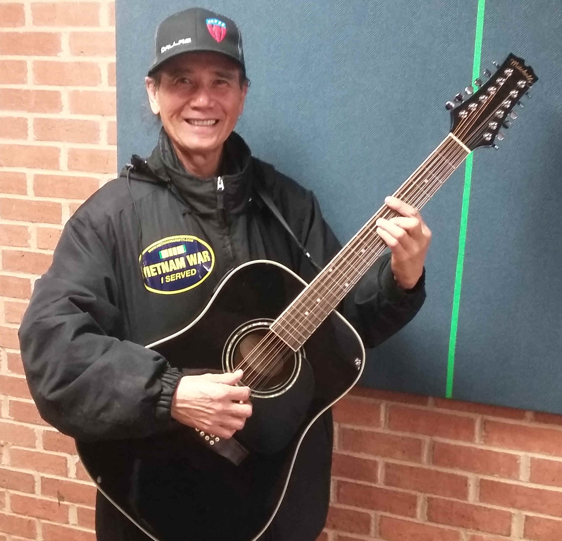
1. Teaching in English: FREE (no charge) GUITAR CLASS FOR SENIOR CITIZENS
- Requirements:
Buy at any GUITAR CENTER, or ONLINE:
1. A guitar: Acoustic or classical guitar, any brand name.
2. A tuner to tune your guitar.
3. A book for PRACTICE: “Hal Leonard Guitar Method Complete Edition”, 3 CDs included, by Greg Koch. Publisher: HAL LEONARD.
4. A book for THEORY: “Alfred’s Essentials of MUSIC THEORY”, 2 CD’s included, by Andrew Surmani, Karen Farnum Surmani and Morty Manus. Publisher: ALFRED.
5. A pencil with eraser, and a notebook for taking notes.
- Class Place: Register at the front desk of
WALNUT STREET SENIOR CENTER
3306 W Walnut St, Ste 300
Garland, TX 75042
- Class Time: Every Thursday
12:30PM – 1:00PM: Practice
1:00PM – 1:25PM: Theory

2. Lớp Dạy Bằng Tiếng Việt: $40 mỗi giờ tại studio riêng, gọi Lý cellular phone (682) 521-0145 để giữ chỗ và biết thêm chi tiết.
http://www.laivanly.com/music/music-classes.htm (Updated: May 25, 2018)

